Record Vessels’ information from camera monitoring images
- Tasks:
Every morning before 10:20, I need to complete recording vessels’ information whom have passed the cameras under monitoring. The recorded information is used to create daily data visualization report which will be sent to our clients daily.
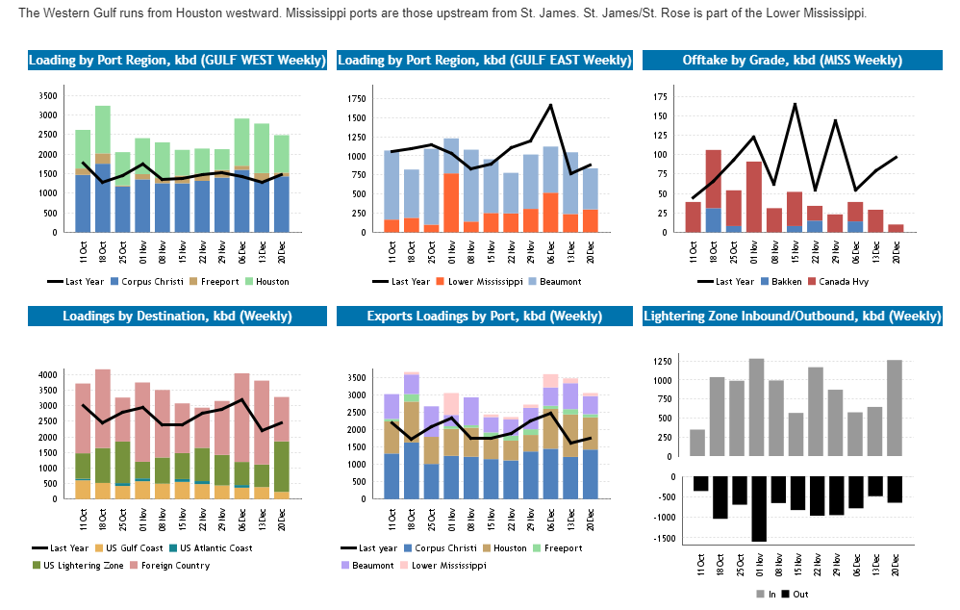
Figure 1: daily report samples
The cameras which under my monitor are set up in Port Neches, Texas (Bosch 11), Pointe à la Hache, Louisiana (Bosch 19), Port Aransas, Texas (Bosch 21), Surfside, Texas (Bosch 22), Matagorda, Texas (Bosch 37) and Sabine Pass, Port Arthur, Texas (Bosch 62).
The following information should be documented to create our daily data visualization report:
- Name: The name of each vessel can be found through PortVision, Bargo Map, ImageSuggest (ISG3). Either way can be applied when looking for the name of vessels who pass through our camera. The most efficient and accurate way is to check the PortVision. It directly shows the scenery of the ports where the cameras are set up on, especially when there are many vessels pass through the camera at the same time, PortVision can help to identify the target precisely.
- Direction: directions can be easily told from the camera real-time images. When many vessels passed through the monitored camera at the same time, “directions” can be used to identify our target vessels especially when recording the names.
- Type and Capability: After record the name and direction of every vessel, it is significant to identify the type and capability. The details are shown as follow：

- Barge/Tug (oil) { 10k (200’*35’), 30k (300’*35’), 20k (10k-30k)} ;
- Pressurized or non-pressurized (gas); === >> Liquid
- Tanker;
- ATB (Engine inserted)

- Tug (different shapes with oil tugs or only tugs carrying nothing)
- Cargo ===>> Dry
- Dry ATB

Tips:
- VesselImage can be used to check the history image pools to verify the types and capabilities;
- The most difference between Tanker and ATB is that the engine/tug of ATB is inserted while the engine of Tanker is above the deck;
- Cargo includes container, elevated or with pipe, “Greenhouse” over the ship and so on. We can easily tell that from the images;
- Barge of 10k, 20k, 30k, ATB will be either empty or full; Tanker is very large, it normally will not be empty;
- Dry barge (other) and liquid barge of 10 k have the same size. (size means length and width here)
- Normally, if LNG or LPG shown on the vessel, we can identify it as tanker
- ISG3 can be used to check any missing ships after recording all vessels’ information
- My location is New York, NY in east coast time zone. The image time zone is 4 hours ahead of east coast time zone.
- In Mississipi Gulf, the vessels go up (goes into the gulf) are usually empty while go down are usually full. However, it should be further considered according to the real-time images.

